Spine & Hinge Creaser Option

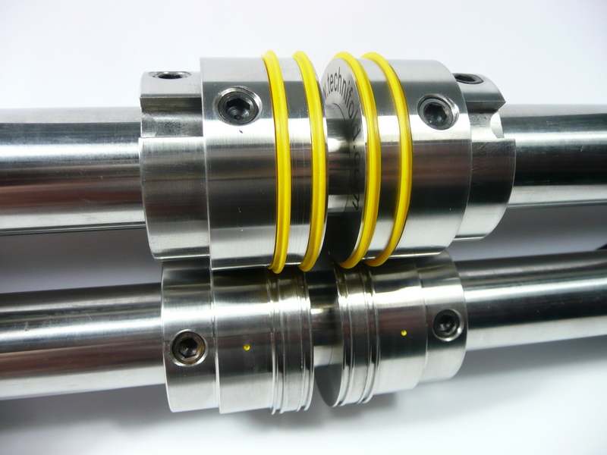
Shaft fixing screw
Crease rib holding collar
B
A

Each of the 4 crease units must be placed in the correct order as shown above.

Setting the Spine & Hinge creaser
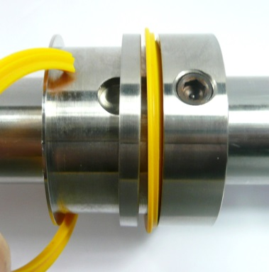
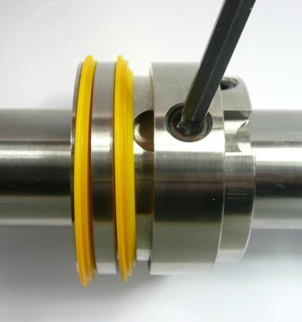

When changing from one stock weight to another you may need to change to another creasing rib according to the chart in Appendix C. The design of the rib makes it quick and easy to do this.

Firstly lift open the shaft cover and use the 4mm Allen key to loosen the shaft fixing screw on the creasing rib holder (see picture above).

Adjust the thickness of the spine by loosening the 4 shaft fixings screws A and slide the 4 components apart until the correct spine is achieved.
To move an individual crease rib holder, use a finger or thumb to lift the calliper adjustment plate upwards. The creasing rib holder will now slide freely along the shaft. The crease ribs have a wedge shape on one edge and a flat side on the opposite side, It is important to place the flat edge on the side nearest the spine
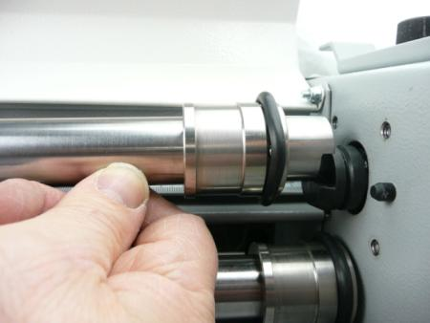
Shaft holder

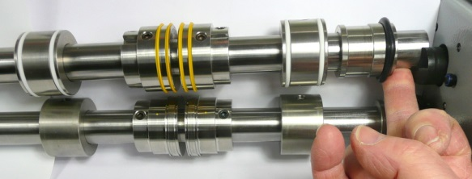

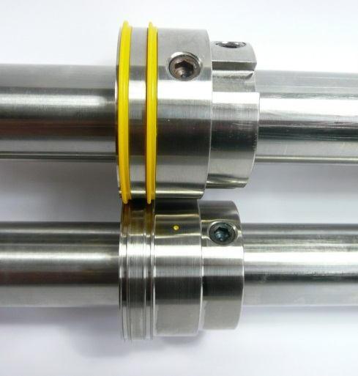
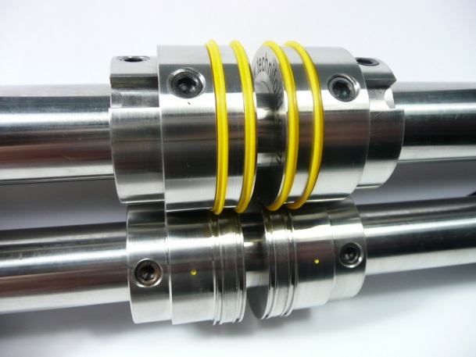

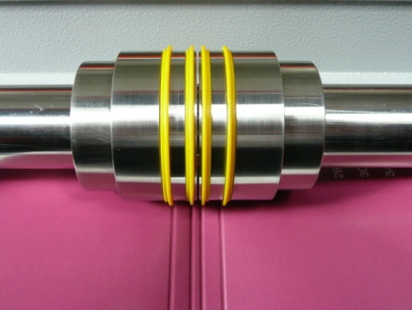
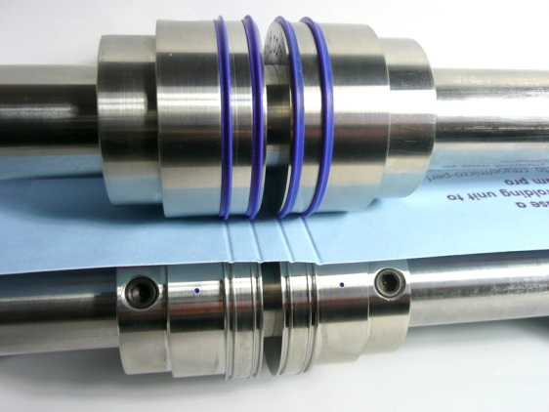

The minimum spine thickness is 3mm Blue settings for paper stocks 150-300gsm
Yellow settings for paper stocks 250-350gsm

Once your crease position has been identified, tighten the fixing screws on the bottom shaft.

Advance a sample sheet through the machine until the sheet has rotated at least 360 degrees and the fixing ring screws are visible.

Once the feed guides and creasers are positioned correctly, take a single sheet of
paper and place it down between the guides. The sheet will automatically align itself
and move towards the adjuster feed tower and then switch the machine on. The
sheet will slowly feed through the callipers, if any doubles occur please slowly tighten
the central adjuster as follows.

